How I Found My Voice (And Why I’m Finally Using It)
May 8, 2025
I’ve always been fascinated by communication.
Not just the ability to speak — but to really convey something that connects. That lights something up in someone else. That lingers.
As a child, I looked up to those I saw as master communicators—teachers, speakers, writers—people who could take abstract thoughts and shape them into phrases that stuck. They had a way of translating what lived in their minds into something clear, almost effortless, and deeply felt.
I didn’t yet have the tools to emulate them, but I wanted to. So I did what made sense to my curious little brain: I happily read dictionaries and thesauruses (if that doesn’t scream logophile, I don’t know what does). I just knew, instinctively, that if I wanted to express myself more freely, I’d need a broader pool of words to pull from.
And hey—if you paused to look up logophile, you may have just taken your first step toward becoming one. Hah!
I devoured documentaries, magazines, and my sister’s high school literature books. Once the internet became accessible, I’d spend hours on the family computer, ravenously exploring article after article across every topic imaginable.
If I came across a word, phrase, or concept I didn’t understand, I wouldn’t stop until I could use it myself—especially in conversation with a grown-up. I had a need to understand, and just as deeply, a need to be understood.

The DVD That Changed Everything
One day, my parents bought my sister and me a copy of Madagascar (2005)— the DreamWorks animated film. It came with trivia games, secret codes, mini-activities… We were obsessed.
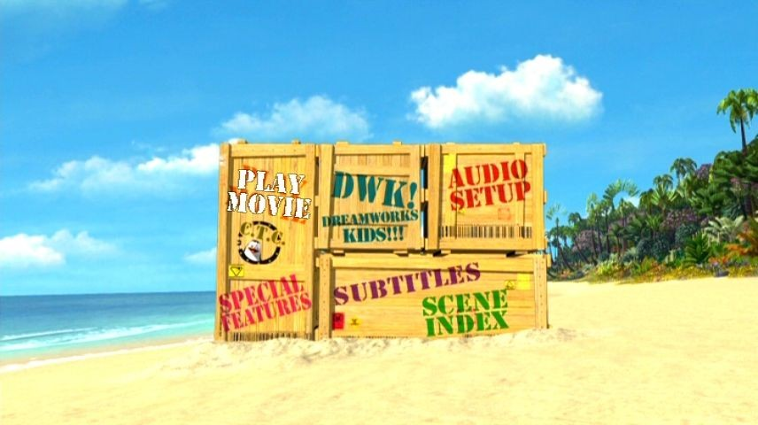
Screenshot of the DVD main menu from Madagascar (2005). © DreamWorks Animation. Used under fair use for commentary and illustrative purposes.
But the part that really caught me — the part I remember most vividly — was buried in the Special Features section of the DVD: a behind-the-scenes look into how the movie was made.

Screenshot of the "Special Features" menu from Madagascar (2005). © DreamWorks Animation. Used under fair use for commentary and illustrative purposes.
Suddenly, this wild, vibrant, hilarious world we had watched unfold wasn’t just “TV land.” It was made. Every frame, every sound, every moment was crafted — not by "magic", but by people.
That changed everything for me.
From then on, I didn’t just want to watch stories. I wanted to make them. My sights were set on my first dream job: Animator.

ENTER STICKMEN (but cool)
In preparatory school, a new trend took hold fueled by the rise of Adobe Flash animations on platforms like YouTube and aptly named StickPage. Suddenly, stick figure animations weren’t just YouTube clips — they were art. Entire fandoms sprouted up around this dynamic, kinetic form of storytelling.
Soon, my classmates started drawing stick figure comics in their notebooks. And of course, I dove in headfirst.
Armed with the back pages of my school notebooks and a handful of ballpoint pens—the only workaround I had for my perfectionism-fueled urge to erase—I started cranking out comic after comic.
At first, they were just silly gags. Then came full arcs. Then whole worlds. The stories grew longer. The characters, deeper. Friends began borrowing my books just to see what happened next.
It was electric.
I even dabbled with tools like Pivot Animator — a simple stick figure animation program — but I never made it too far there. The software didn’t stick (hehe). But the storytelling? That did.
What I didn’t realise at the time was this: People weren’t drawn to my comics because the art was phenomenal (trust me, it wasn’t). They were drawn to the narrative, the story.

Might Be Onto Something Here
When the gap between my ambition and artistic ability became hard to ignore — especially surrounded by peers with genuinely awe-inspiring art skills — I began stepping back from comics.
But I didn’t stop creating. I just found a new medium: writing.
It had always been there — buried in the margins of everything I did. And now, it came roaring forward.
I started entering my school’s poetry competitions—at first under a pen name, convinced I wouldn’t place. I won (2017). Then I won again (2018). Eventually, I entered a short story competition—hesitant at first, but bolstered by praise from an after-school programme. I won that, too (2019).

Collecting my second Wolmer's Boys' Poetry Competition Trophy in 2018 (and my proud mom)
And somewhere in the midst of all that, I even tied for fourth in the Wolmer's Boys' School Monica Sterling Essay Competition (2019)—as the only bulla shirt (our nickname for the full khaki worn by students not yet in sixth form) to walk up for an award… though that meant I just missed the cash prize. Tragic, I know.

Collecting my 4th place prize (a bit disappointed that I missed out on the cash prize 😂)
Suddenly, for the first time in my life, I wasn’t trying to somehow draw better to tell a better story. I was telling the story in the way that came most intuitively for me. With words.
But just as I was starting to think “Writer” might be the final form, something else quietly snuck in.

Marketing Has Entered the Chat
Even before I knew the word “marketing,” I had a feel for it.
Back when my mom worked at Mother's Food Group, she once brought home a leopard-print gift bag full of fragrances. To most people? Just packaging. But immediately, the patty bag-like shape got my gears turning.
I was still in prep school at the time, but I remember confidently pitching her this “Go Wild” idea — Jungle-themed healthy meals and fruit juices with big-cat-printed patty bags and cups.
In short, nothing came of it (bummer). However, she smiled, acknowledged my effort and said it was a clever idea. And for the first time I heard, from her, the word marketing. It kind of had a nice ring to it.
Years later, I saw the Bachelor of Science in Marketing programme on a brochure at a booth by University of the Commonwealth Caribbean (UCC) during a career day fair in high school.
Something clicked.
I went down a research rabbit hole and this was it! The new calling.
Because what is marketing, if not strategic storytelling?

Fast-forward to Now
Today, I’m a digital content creator, with a focus on content marketing initiatives across various platforms. I have a particular passion for crafting stories through videos, voiceover work and, of course, the good ol' written word.
And while I’m still building my way forward, I’ve learned something valuable:
In today’s noisy, digital-driven landscape, new approaches are needed to maximise success.
That’s what this newsletter is about.

Welcome to Creator’s Current
This newsletter isn’t some expert playbook or crash course in viral growth (if I do find that secret formula though, you'll be the first to know). It’s little finds, honest insights, and lessons learned in motion.
It’s for fellow creators and small brands navigating ever-changing tools, unpredictable algorithms, and platforms that switch things up on a whim.
Here’s what you’ll find here:
- Behind-the-scenes insights from my messy, growing creative life
- Storytelling tips (visual and otherwise) that actually work—for real people, not just brands with ten-person teams and infinite budgets
- Heartfelt stories about the creative life when you’re still figuring it all out
- The occasional deep dive into why certain content just hits (and why some flop)
I’m not necessarily writing from a mountaintop of enlightenment. I’m right here with you—making it up as I go and sharing what I pick up along the way. Think Let’s Play, not Walkthrough. (And yeah, streamers and TikTok clips kind of hijacked those, didn’t they? Oh, how times change.)
My goal isn’t to hand you all the answers, because even if I let you copy my homework exactly, you still won’t get full marks... trust me.
That said, some issues of this newsletter (like uh, the next one) will take a more zoomed-out view. Diving into research, frameworks, and what the data actually says about how content connects. Not because I’ve mastered it all, but because I’m genuinely fascinated by it. Also, I figure if it helps me think clearer, it might help you too.
So whether you’re here for the messy behind-the-scenes, the nerdy deep-dives, or just the occasional creative nudge—welcome. You’re in the right place.
👉 Hit Subscribe to join the current. Who knows? You might just find something worthwhile.
Until next time,
Velton

Recalibration: Reset, Refocus, Return
September 22, 2025
Most creators don’t stop because they want to.
They stop because they have to.
Since 2021, life in corporate gave me some real highlights, new skills, and the kind of speed you only get by being thrown into the deep end. I’m genuinely grateful for that season. But the urgent kept expanding until it crowded out the essential. Spiritual balance. Health. The slower work that actually grows the craft.
The pause in this newsletter wasn’t disinterest; it was a bandwidth issue. Too many dials spinning, and not enough time to check whether they still pointed to reality.

A thought came to me about the Bureau of Standards Jamaica, and the breadth of work that goes into keeping national quality systems steady. In the Metrology Division is a team that focuses on calibration i.e. checking whether instruments are still telling the truth.
Scales drift. Gauges wander. A tiny error in the morning can become a catastrophic mistake by afternoon. Calibration brings everything back to a trusted reference so the numbers mean what they claim to mean. That picture stuck with me.
I needed something similar.
Not a rebrand. Not theatrics.
A recalibration.

Reset
Reset begins with honesty. If you never stop to read the panel, you will keep turning knobs that do not matter.
Here is what I finally admitted to myself.
Activity had become camouflage. My calendar looked heroic. Meetings, drafts, campaigns, late-night “one more edit”. I called it commitment, but it was also a hiding place. If I filled every hour, I could avoid the big, intimidating work: building a business with my name on the invoice, taking up space in rooms with clients who operate at scale, letting my ideas stand on their own. Busyness gave me a convenient alibi.
I was shrinking behind the myth of safety. We are told the stable path is the safe one. Turn up, keep your head down, do the right thing, and you’ll be fine. I learned first-hand that “stable” is a story organisations tell until the numbers say otherwise. There is wisdom in steady work, yes, but the safety blanket had become a blindfold. I needed to see again.
The future I was rehearsing did not look like a life. Picture a family in that world. Too busy to spend time with my mate. Perhaps, someday a burnt-out father with nothing left by 7 p.m. A flat battery dragging itself to the charger each week. That image hurt. It also helped. You cannot build a life around the people you love if you keep placing them in the margins. In my case, I knew I had a choice.
My reference had drifted. For me, that reference is Bible-based. When that moves to the edges, the day gets noisier and my decisions turn reactive. I want what I claim to value to show up on my calendar, not just in my mouth.
Reset meant stripping away the noise, facing the drift head-on, and giving myself permission to start again with clarity (even if it brought with it uncertainties).

Refocus
Refocus is returning to the reference that does not move, then letting everything else align around it.
Here is what that looks like for me.
Make time for the more important things first. Not when the inbox allows it. First. Bible reading, personal study, prayer. Engaging in the ministry. Room for rest, friendship, and the small acts that keep my conscience clean, and my head clear. When those are in place, my day breathes. When they are absent, the day runs me.
Reorder the work so it serves the life. I am stepping away from the 9 to 5 model for a while. Not as a rebellious charge, but as a thoughtful test. I want my creative and professional activity to surround, and fund, my theocratic work. That is the non-negotiable axis. The rest of the wheel can turn freely, but the hub stays still.
Choose presence over omnipresence. I will not be everywhere. I will be where the work is real and the relationships survive an algorithm change. Fewer rooms. Clearer voice. Better conversations.
Replace bravado with practice. I am leaving space to stretch the craft again. Not just grand campaigns and nebulous "productivity". Daily, visible effort. Small pieces that look like play but build capability. Less theatre. More training.
Refocus is not becoming smaller. It is becoming aligned. Trade-offs get cleaner. What used to feel like FOMO starts to feel like focus.

Return
Recalibration is not just about work rhythms or publishing cadences. For me, return means stepping back into life with a clearer compass.
It means returning to spiritual activity as the fixed point everything else revolves around. It means being present with people I love instead of just “available” when the schedule allows. It means building systems in my business that support the life I want to live, not the other way around.
The return is not to noise or speed. It is to balance. To a way of living where content creation, client work, wellness, and rest all find their place under a bigger order of priorities.
That looks different for each of us. For me, it means structuring my days so I can serve in the ministry, nurture relationships, and still sharpen my craft. For you, it may look like reclaiming evenings, cutting a channel, or saying no to one more “urgent” thing that doesn’t actually move the dial.
Return is not about going back. It is about re-entering with alignment and living in step with what matters most.

The instrument, tuned
Calibration has a close cousin: tuning. It’s the same idea in another domain. You check yourself against a reliable reference so what comes out is true.

Think of a simple instrument. You can practise for hours, but if it isn’t tuned, all that effort just teaches your ear to accept the wrong pitch. Tuning isn’t flair; it’s what makes the practice count. Life works the same way. Align to the reference, then play. Check again, then play. Short, regular turns keep the sound honest.
Two gentle truths help here:
1) Tune to the reference… and to the room. Yes, you start with a fixed note. But once you’re in the room with other people, you listen and make small adjustments so everything sits well together. Same with work. I hold to an unchanging reference (my Bible-based priorities), then I pay attention to the people I serve. If my “perfect” plan clashes with reality, the audience hears the wobble. The aim is harmony, not stubbornness.
2) Expect drift while you’re playing, not just between songs. Heat, movement, time… they all pull a string a little off. Goals do this too once they meet real calendars, clients, cash flow. Build in micro-retunes: a five-minute check at midday, a quiet reset at week’s end. You’re not failing if you adjust mid-piece. You’re being attentive.
One last thing musicians learn quickly: you don’t fix a sour note by playing harder. You fix it by listening better, then making a small, precise change. That’s recalibration in a sentence.

A few snapshots of recalibration in the wild
Not promises. Not prescriptions. Just practical patterns you could try, and feel within a few weeks.
1) If you lead a brand and feel spread thin You might narrow active channels from “everywhere” to two that actually convert, set two daily response windows (late morning, late afternoon), and protect a three-hour focus block in the team calendar. Likely results: fewer fake emergencies, cleaner deliverables, decisions that move budgets.
2) If you’re an independent designer with feast-or-famine weeks You might reserve Monday mornings for proposals only, turn invoicing into a 15-minute Friday ritual, and add a two-line debrief to each job: “what worked / what repeats”. Likely results: stronger win rate when your brain is fresh, steadier cash flow, reusable patterns instead of reinventing every time.
3) If you run social for a small organisation You might pause daily posting, audit the last 90 days, and find five moments that did most of the work. Rebuild around those with variations, ship one weekly pillar and two lightweight follow-ups. Likely results: engagement that comes from clarity, less calendar panic, more space to listen.
4) If you sell online and trust is slipping You might retire a handful of slow variants, double down on a hero product, and make one clear promise (e.g., next-day dispatch, 30-day returns, no quibbles... that's a funny word isn't it? Anyways). Likely results: fewer choices, faster fulfilment, reviews that mention “service” and “consistent quality”.
5) If you’re a creator burned by endless output You might work in seasons: record a batch in two weeks, edit in one, publish over six to eight, then take a short break to learn and adjust. Likely results: output that feels lighter, content with room to breathe, momentum by design rather than panic.
None of these require a personality transplant. They ask for one brave constraint, a clear reference, and the will to hold that line even when the inbox protests. Adapt the idea to your instrument and your purpose, then let the small, honest turns do their work.

Why this matters if you are burnt out
Because the current “be everywhere” culture quietly punishes people who care about craft. Because you can ship a lot and still say very little. Because omnipresence is expensive, and presence is priceless.
You do not need a 47-step plan to begin. You need honest readings and small, steady corrections. Ten quiet minutes before the house wakes. One evening protected like glass. One obligation trimmed to a humane size. The next hour is a choice, even when the whole month is not.
A brief note I will unpack another time: I am neurodivergent. That reality shapes how I design my days. Low friction. Flexible where it helps. Routines that bend without breaking. If your brain loves novelty or time has a way of being slippery, there is still room for you to reset, refocus, and return. Trust me.

Closing
Reset, so you can see clearly. Refocus, so the day serves the reference. Return, with a cadence you can keep.
I am stepping away from the world of corporate for a while to reprioritise my personal business and the brand-building systems that support the work I am called to do. I want a future where the people I love are not surviving on leftovers. I want the work to be honest, not theatrical. I want the instrument to tell the truth.
Maybe you cannot change course dramatically. Most people cannot. You still have choices about where the next hour goes.
Accuracy over activity. Drift is natural. Correction is chosen. Hold to a reference that does not move.
I will be here, quietly checking the dials and making one more careful turn. If you are recalibrating too, I am cheering for you.
Until next time,
Velton

Cut Through, Don't Shout: The Power of Minimal Signals
May 21, 2025
Most small brands try to outshout the giants… and lose their voice in the process. (Ouch.)
It’s tempting, right? Post more. Yell louder. Crank out content like your life depends on it. But let’s be real: that’s a fast track to burnout — not a breakthrough.
What if the goal isn’t to be louder... but sharper?
This is where Signalling Theory enters the chat. At its core, it’s based on a simple truth: information asymmetry — one side knows something the other doesn’t.
Signals are sent to bridge that gap. A cue. An action. A move that reveals quality or intent.
But not just any signal will work.
A signal must be:
- Credible (believable),
- Efficient (worth the cost of sending)
Minimal signals aim for that sweet spot.
Substantial enough to tip the scale, but light enough to remain agile.

Closing the Gap
Effective signalling isn’t about flooding feeds or blanketing airwaves. It’s about being intentional. It means making moves that feel right for where you are, and who you're trying to reach.
Minimal signalling leans into that idea.
It’s not about doing less to avoid the work — it’s about doing what works.
Choosing the kind of actions that mean something. The kind that linger long after.
This isn’t just me talking. There's a basis for this approach:
Connelly et al. (2011) found that the most effective signals strike a balance: they’re believable, but also efficient.
And Számadó (2011) makes an even bolder case. Not all honest signals have to be costly. Sometimes, the lightest gestures carry the deepest weight.

The Noise Problem
The instinct to "outshout" competitors...
Crank up ad spend, post endlessly, flood inboxes!
...made sense when volume equalled visibility.
Now? It backfires.
Audiences aren’t just tired. They’re tuned out.
It’s like nose blindness: the longer you're exposed to a strong scent, the less you notice it. Your brain tunes it out.
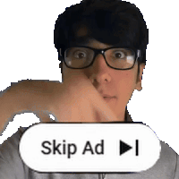
This is what overexposure looks like in real time.
Marketing noise works the same way. Overexposure dulls attention until even the loudest messages fade into the background.
Economist Herbert Simon warned us.
In an information-rich world, attention becomes the scarce resource.
Modern marketing often looks like sprinting on a treadmill that’s speeding up faster than your legs can move. More effort doesn’t always equal more traction. Just exhaustion.
If you’re a solo creator or small brand, the answer isn’t to run faster.
It’s to step off... and start signalling smarter.
Instead of shouting louder, the goal now is to change frequency:
- Sharpen your targeting: Speak to fewer people, but the ones who actually care.
- Shift your tone: Lower. More personal. More resonant.
- Prioritise emotional impact: Trade breadth for depth.
This isn’t just theory. Small players have already been winning this way.

Case in Point: CardBuddy
Let’s take a look at a small business that used minimal signals to powerful effect.
Sam Feldman, a college student at the University of Maryland at the time, launched CardBuddy — a brand selling stick-on phone wallets.
He had no investors, no marketing team, and no elaborate funnel.
Just an obsession with surprising and delighting customers in small, intentional ways.
In a Reddit post from 2017, Sam shared how he:
- Hand-signed over 12,000 thank-you notes in the early days — adding a human touch to every package
- Tucked $1 bills into 1 out of every 5 orders, creating a moment of unexpected joy for customers at just 20 cents per unit
- Replaced defective products generously, once sending a frustrated customer ten new wallets — including premium leather ones — just to turn a bad experience into a lasting impression
To measure the impact, Sam did a small study of his Amazon reviews. Where his top competitors had just around 2–4 mentions of the word “service” per 1,000 reviews… CardBuddy had closer to 63.
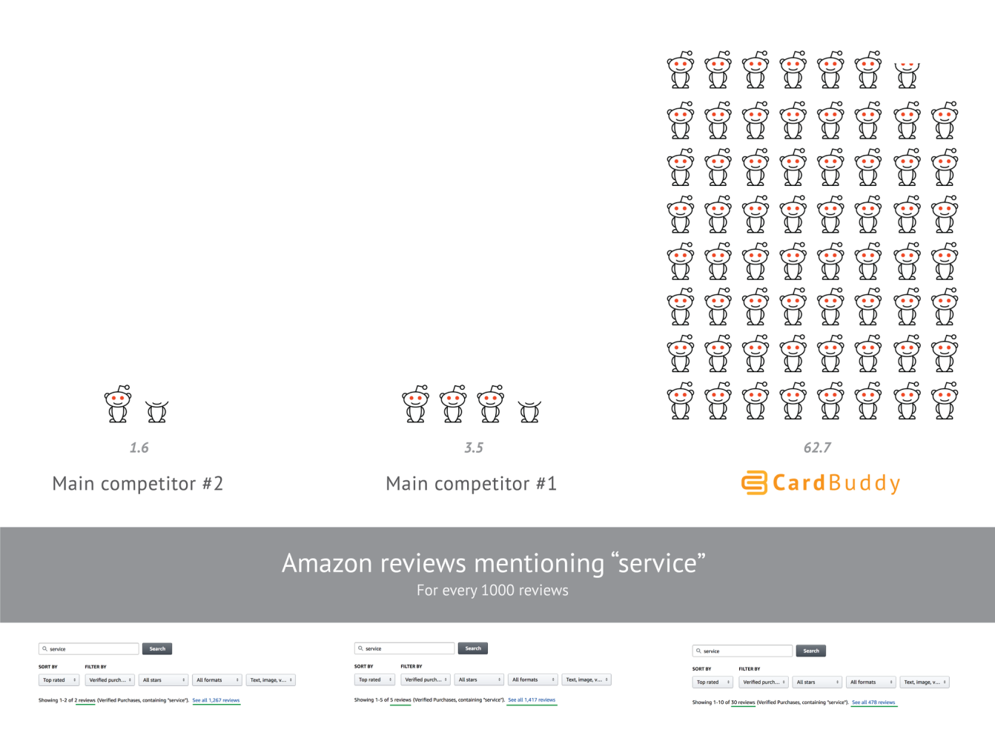
A visual breakdown of how often ‘service’ was mentioned in Amazon reviews per 1,000 reviews. CardBuddy’s minimal, personal touches outperformed its closest competitors by a wide margin.
That kind of reputation wasn’t built through ad spend, but through small, consistent signals that meant something to the people receiving them.
These gestures helped Sam turn CardBuddy into a six-figure business while still in university, and earned him the title of Student Entrepreneur of the Year from the Dingman Center for Entrepreneurship in 2016.
Minimal signals. Maximum impact.

Nature’s Reminder: Lessons from the Shrewd Bird
In nature, when resources are plentiful and the stakes are low, extravagance tends to win — especially in the mating game:
- Louder calls.
- Brighter feathers.
- Longer dances.
But when space shrinks, noise becomes a liability.
The shrewd bird doesn’t scream louder. It adapts:
Placement over noise: It doesn’t waste energy calling into the void. It appears where attention already gathers — at watering holes, perches, clearings where a potential mate is likely to notice.
Offerings over boasting: It doesn’t just strut and shout. It brings a berry, a twig, a small but meaningful gesture— a sign of value, not vanity.
Subtlety over spectacle: While rivals exhaust themselves in flamboyant displays, it conserves energy and reads the room. A still tilt of the head. A soft wing flutter. A well-placed chirp at just the right moment.

Photo by Wei86_Travel🇹🇭 .th:
I’m no ornithologist, to be clear (that's a bird expert by the way, saving you the trip to Google). More of a casual documentary watcher, really... but the illustration remains.
This strategy doesn’t promise overnight wins. But it increases the odds, while also conserving strength for the next hurdle.
Today’s marketplace mirrors that packed forest. Everyone’s shouting:
SALE!
NEW DROP!
LIMITED TIME ONLY!
But customers aren't listening like they used to.
The opportunity now lies in playing a different game.
Minimal signalling doesn’t mean doing less. It means showing up with clarity.

How You Can Start
You don’t need a big budget to put this into action.
Here are three moves you can make this week:
- Audit your presence: Look at your Instagram bio, WhatsApp Business page, or website. Are you signalling clarity or confusion? Instead of “Freelance MUA,” imagine: Bridal and Editorial Makeup | Kingston, Jamaica.
- Sharpen your focus: Define your brand’s emotional core. A small plant shop might centre around: "Making plant care simple and joyful for every home." Now align your content, tone, and offers to support that message.
- Act small, but smart: Pick one high-impact gesture this week. If you’re a jewellery maker, spotlight a loyal customer styling your piece. Take out your phone and film a video thanking them personally on your IG Story. It builds connection and community... far better than a boosted generic post ever could.
The cost of yelling will only keep rising. But thoughtful connection still works (and even compounds over time).

Final Thoughts: Building Signals That Matter
Exploring Signalling Theory in the context of brand-building has helped me realise something I’m still working on myself:
In a world drowning in noise, real connection is what lasts.
Sure, more content and bigger campaigns have their place. But realistically… can you really out-shout the giants?
Furthermore, it’s the minimal signals that actually reach people in a way that matters.
Honestly, though? I still have a looong way to go before I can confidently say I'm practicing what I'm preaching here.
But as a creator and marketer, this lesson has helped me to care less about omnipresence and more about, well... presence.
Since that shift, something’s changed.
The pressure’s lighter. Procrastination, in my personal branding efforts, is turning into progress. (I mean look at this article I just wrote!)
Not because I’m just doing more, but because I’m finally doing what matters.
P.S.
I want to acknowledge that this article was inspired in part by the article on the People Tutorials newsletter, Marketing Doesn’t Have to Be Loud by Dominic de Bourg.
If you found this perspective valuable, I highly encourage you to read his article as well. It offers even more practical, actionable insights on navigating marketing in today’s saturated space.
Alrighty then.
Until next time,
Velton

The Creative Archive: Finding Narrative in the Neglected
September 29, 2025
Every so often, the drive to create pauses long enough to look backward.
In those moments, opening an old folder or rummaging through that one drawer doesn’t just reveal the forgotten, it points to earlier versions of yourself waiting there. Sometimes the mess of old drafts and files is really just a record of progress, each piece carrying a trace of how far the journey has come.
That happened while tidying my Google Drive earlier this week. I went in to free up some space and feel virtuous. I came out with a small pile of artefacts that refused to be deleted.
It showed me why certain themes keep circling back, why some formats always feel natural, and why even the so-called “bad” drafts hold an undeniable charm.
That’s when it clicked. An archive isn’t just storage...
It’s a story.
And, if treated with a little care, it becomes fuel.

Why we rush past what we’ve already made
Momentum is usually tied to novelty. Platforms reward the newest upload, clients want something fresh, and our own standards rise quickly enough that yesterday’s work starts to feel clumsy. It often seems easier to keep moving forward than to linger on what came before.
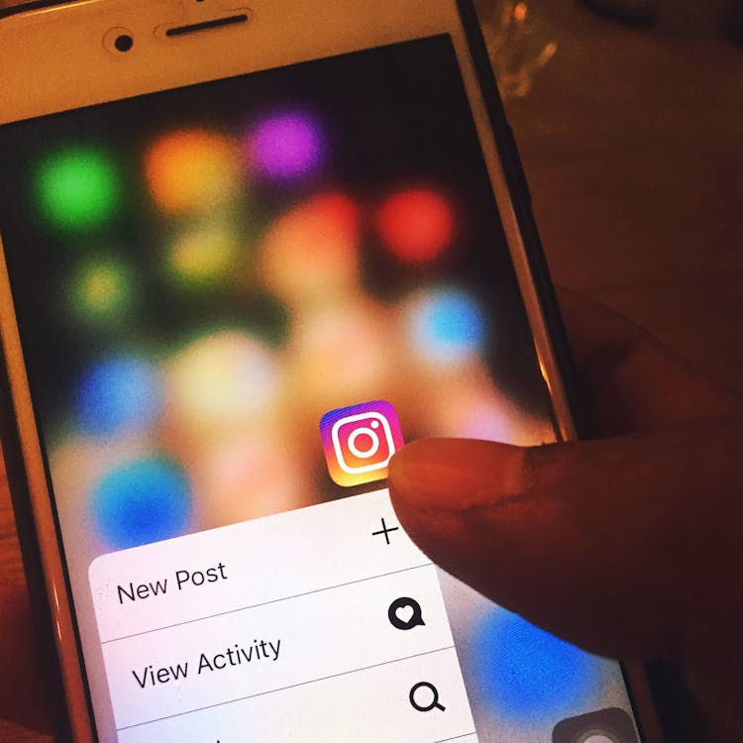
But when everything is measured by what’s next, we overlook what’s already there. That quick rejection of old work can strip away valuable insight. A half-formed idea that didn’t work at the time might connect perfectly with something you’re exploring now.
The rough edges can point to instincts that were true long before the polish arrived. And those imperfect drafts, instead of being proof of failure, are actually the receipts of growth.
Archives also provide a mirror. Looking back highlights patterns, habits, and recurring ideas that don’t always feel obvious in the moment. What once looked random begins to reveal a rhythm. That rhythm isn’t just sentimental, it’s the blueprint for a voice, a brand, or a creative identity taking shape.
The rush for recency also ignores the fact that audiences enjoy context. They may discover you through a recent post, but when they scroll further back and see your beginnings, it makes the story richer. The leap from early clumsy work to more polished output makes progress relatable, and relatability builds trust.

Preservation, not hoarding
There’s wisdom in clearing space, but minimalism taken too far can erase the very fingerprints that prove a journey happened. Deleting everything that feels embarrassing risks losing the texture that gives a story weight. The line between clutter and evidence is thin, but it matters.
Preservation isn’t about keeping everything. It’s about recognising which pieces carry meaning beyond their surface. I was reminded of this when I stumbled on an old photo that almost disappeared from memory. Back in 2017, armed with a Nokia Lumia 1020, I snapped a shot at Dovecot Memorial Park and casually sent it to The Gleaner’s weekly Shutterbug feature.
I didn’t think much of it at the time, just a youth sending an email, but to my surprise it was selected and published. I only rediscovered it years later while running a Google search of my own name. That unintentional act of archiving became part of the record, and looking back at it now, it feels like a small but powerful reminder of how preservation works in ways we don’t always expect.

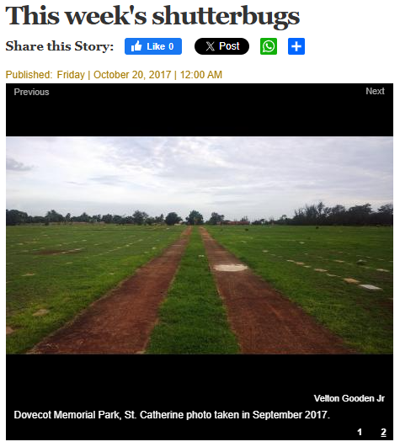
Screenshot courtesy of The Gleaner, Shutterbug, 2017
So archives are a bit like soil. Not every seed planted will sprout, but the richness comes from the mixture of what succeeded and what failed. By preserving artefacts selectively, you build a kind of creative compost that fertilises what comes next. The point isn’t to live surrounded by relics, but to curate enough history that the present has depth.
Documentaries prove this all the time. It’s rarely the narration alone that makes them powerful, it’s the objects, the photos, the scraps of paper that anchor memory in something tangible. The same principle applies to creative work: without artefacts, stories float. With them, they land.
The preservation mindset also adds emotional honesty to creative identity. When you share the raw or awkward parts alongside the polished, it signals authenticity. It shows that the current level of craft didn’t appear overnight, but was earned through time and mistakes.

From memory to momentum
Preservation can also fuel forward motion. Raw material set aside becomes a stockpile for days when inspiration feels thin. What looks like scraps today can become the spark tomorrow. The important thing is not just to keep these items, but to revisit them with intention.
Looking ahead, this is where I want to weave more of the archive into my content. Rather than treating all old files as throwaways, I plan to fold some back into the work I share, sometimes as quiet references, sometimes as visible anchors.
I’ve already seen how an image or a snippet from the past can bring an unexpected layer of authenticity, like in the opening edition of this newsletter. Going forward, I intend to tap into that more often, letting the old and the new sit side by side, to show process and continuity. Over time, I want the archive to stop feeling like storage and become a bigger part of the storytelling itself.
I imagine this will take the shape of more deliberate throwbacks, weaving fragments of old media and moments into new content. Not just as decoration, but as connective tissue that shows how ideas evolve. By letting those fragments resurface, the content can carry both continuity and contrast, evidence that growth isn’t about abandoning the old, but carrying it forward in new ways.

What an archive can surface
A dive into the past often reveals more than expected. The immediate instinct is to cringe, but with a softer lens the archive tells a different story.
- A map of themes. Over time, recurring threads start to appear. Maybe humour keeps sneaking in, even in serious work. Maybe visual storytelling feels more natural than text. At first, these things look scattered, but zoomed out they reveal a lane. The archive highlights not randomness, but rhythm. Recognising that rhythm can help set a clearer creative direction.
- A kinder metric. Measuring old work against current standards always makes it look weaker. But measuring it against honesty, was this true to me at the time, changes the evaluation. By that metric, much more qualifies as valuable. It may not be flawless, but it is authentic. This way of looking reframes “failure” as evidence of effort, and evidence of effort is what builds mastery.
- A practical buffer. There’s also the very real benefit of having backup material. When schedules are packed, the archive provides a rhythm without resorting to filler. A half-finished draft can be completed. A clip can be reframed. A thought can be expanded. Instead of silence or burnout, the archive supplies continuity. For anyone who has struggled to stay consistent, this is an underrated safety net.
The more it’s revisited, the more the archive stops being a graveyard and starts being a garden. A place that not only remembers the past but actively nourishes the present.
And perhaps most importantly, the archive provides perspective. It lets you compare the distance between where you were and where you are now, not in a superficial sense of improvement but in a deeper sense of consistency. It shows which instincts have remained steady across years, and which skills have been layered on top. That kind of perspective is easy to lose when you’re caught up in the day-to-day push to produce, but the archive quietly keeps score in a way that feels grounding rather than pressuring.

Preservation as a creator’s discipline
Preservation isn’t nostalgia. It’s discipline. The act of keeping just enough to build stronger stories later. A snapshot, a note, a recording, even a childhood report card that planted a seed. If the object can’t be kept, at least capture its existence in words.
Joe Pulizzi, in Content Inc., frames this through content audits: reviewing the work already done to find themes, strengths, and gaps. A personal archive works in much the same way. It is an ongoing audit of your creative self. Instead of reinventing from zero, you refine what’s already there. Instead of constantly chasing novelty, you allow continuity to deepen the message. The habit compounds: over time, the archive becomes not only a safety net but also a library that strengthens creative authority.
The impact of preservation becomes visible years later. The creator who keeps enough of their past has stories layered with proof and history, while the one who discards too much risks producing work that floats without roots. Practicing preservation ensures that creativity doesn’t just sprint forward but grows with depth.

Closing
The archive isn’t just some museum of who you used to be. It’s a living reservoir. Opened with kindness, it reveals context, ideas, and proof that a voice has been trying to speak for a long time.
Presence doesn’t always mean chasing the next thing. Sometimes it means going back, lifting what was left behind, and giving it new life.
That’s the work ahead: digging up memories from the drawer, finishing unseen pieces that deserved better, and giving old work a second breath. And if you choose to look through your own neglected folders, you might find there’s more narrative there than you remember.
Because sometimes, the archive isn’t looking backward. It’s already pointing you toward what comes next.
Until next time,
Velton

Why "Doing More" Often Leaves You With Less

January 20, 2026
You can’t “want” more energy into existence.
I saw a reel from a content creator on Instagram who I genuinely respect. He was making the case that if you have giant ambitions, the answer is to just do more. More work than most people would tolerate. More than you even think you have in you.
And I have no doubt he truly believes it, for good reason. That mindset probably carried him far.
Without the caveat of sustainability though, that message can quietly turn into a one way ticket to burnout. The ambition is not the issue. It’s how most people interpret “more,” as pure addition with no subtraction, and energy does not work like that.

The “more” that becomes self-deception
There’s a version of “more” that is basically just self-deception.
It’s the version where you keep everything the same, keep everybody happy, keep all the commitments, keep the same messy routines, and then try to force an extra 20 percent on top through sheer willpower. That is a loan dressed up as discipline.
And that debt always comes due.

It can look like adding one more client, one more committee, one more favour, one more “quick call,” one more course, one more gym plan, one more content schedule, all while pretending sleep, recovery, thinking time, and basic life admin will somehow fit in the cracks.
Your calendar might say it’s possible. Your energy will say otherwise.

Hyperbolic discounting (a mouthful I know)
There’s a term for one piece of what’s going on here, and it sounds complicated, but the idea is simple. It’s called hyperbolic discounting. Basically, the brain treats immediate rewards as louder and more “real” than future costs.

So the pull of a little doomscrolling as a quick break feels urgent. The payoff of going, “Sure, I’ll just figure it out,” is immediate. It feels good because the cost is delayed. In the moment, you think, “But of course.” Later, you realise you played yourself.
We keep overestimating our future capacity. We assume tomorrow’s version of us will be less tired, more disciplined, more motivated! So we borrow freely from that imagined surplus. However, tomorrow does eventually arrive, bearing yesterday’s decisions, not a fresh balance. By the time you notice the damage, the pattern has already been set. And so the cycle continues.

The lesson I’m still learning
I wish I’d learnt the core points discussed here from yet another productivity book or elaborate study (I’m sure it’s in one). But the last few months have taught it to me the good ol’ fashioned way. Only afterwards did I learn the explanations that helped it all make sense. I tried to blindly do more in pursuit of some short-term goals and it created friction, strained a few key commitments, and brought something that meant a lot to me to a natural close once reality had its say.
To take on “more,” making room is the entry fee. If I want to go harder in one direction, something else has to get cut back. Most of the time it is not dramatic at all. It’s a sober trade. Less of this so I can do more of that.
For a season.

Energy, not time

Energy doesn’t appear out of thin air (physics baby!). It gets converted, and some of it gets lost in the process. Finding “extra space” on a calendar does not automatically mean you have the energy to execute well, repeatedly, without it costing you somewhere else over time.
Lately I’ve been seeing more people move away from “time management” as the holy grail, and lean into something that feels way more honest: energy management. A free hour on paper is meaningless if you arrive there depleted.
Productivity then starts looking less like squeezing tasks into gaps, and more like designing your days, weeks, and months so your best energy shows up when it matters.
Sometimes this exercise of making room looks like saying “no” more often than feels polite. For those of us who, to put it nicely, aim to please, the person it guts the most is you, because you are used to proving utility through availability. It can cost you comfort, convenience, and a few of the little badges you quietly prided yourself on. It might even cost you certain relationships, or at least force them to adjust.

A better question
The question is not “Can I do more?” It’s “Do I want this enough to rearrange my life around it?” If the answer is no, that's telling you something.
Until Next time,
Velton

